**Student Management System**

Group 23

**Group Members**

- Sagar Mittal : 19ucs182

- Sanyam Lodha : 19ucs 258

- Tanmay Lodha : 19ucs221

NPM packages used

const express = require('express');

const bodyParser= require('body-parser');

const ejs = require('ejs');

const mysql = require('mysql');

const app = express();

Connection with MySQL database

const db = mysql.createConnection({

host : 'localhost',

user : 'root',

password: 'password',

port: 3306,

database: "stms"

});

db.connect((err) => {

if(err){

throw err;

}

else{

console.log("connect with my sql");

}

});

**Login Control**

app.get("/" , function(req,res){ //receiving login request

res.render("login");

});

app.post("/",function(req,res){ //checking validity of login credentials provided with database

let sql = "select * from admins where username = '" + req.body.user + "'" + " and passkey = '" + req.body.password + "'";

db.query(sql,(err,result) => {

console.log(result);

if(!result.length){

console.log(result);

res.render("error");

}

else{

console.log(result);

res.redirect("/home"); // rendering homepage after validation

}

});

});

**LOGIN page HTML code**

<%- include("Header") -%>

<h3 class="login">Login</h3>

<div class="loginform">

<form class="" action="/" method="post" >

<input type="text" name="user" value="" placeholder="Name">

<br>

<br>

<input type="password" name="password" value="" placeholder="passkey">

<br>

<br>

<button type="submit" name="button" class="btn btn-primary">Login</button>

</form>

</div>

<%- include("Footer") -%>

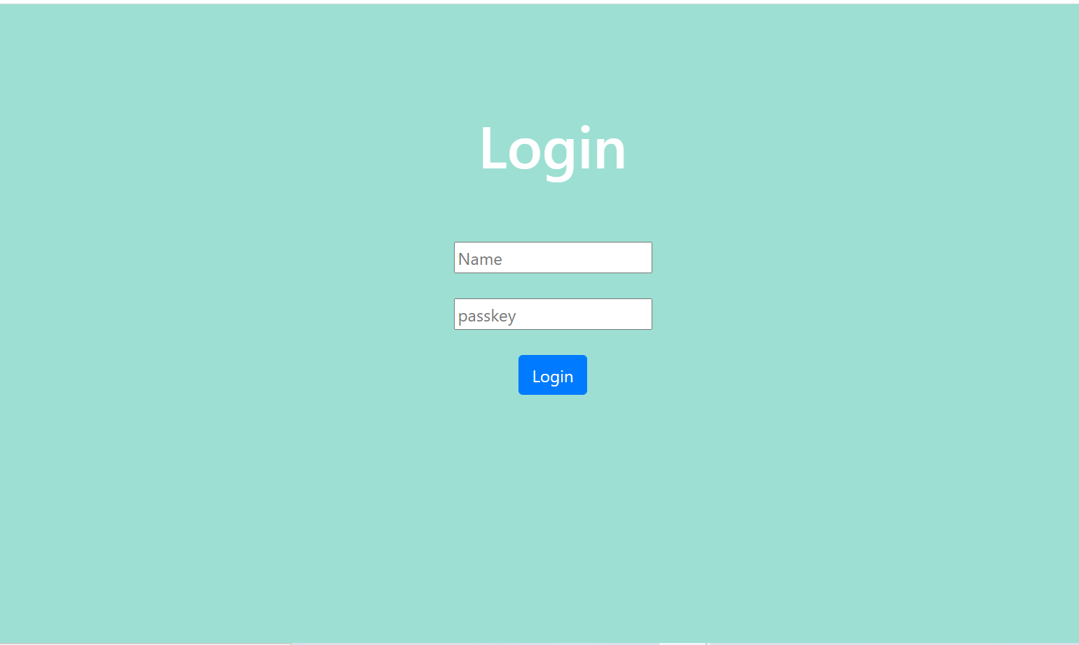

**Home Page Control**

app.get("/home",function(req,res){ // rendering home page

res.render("home");

});

HOME page HTML code

<%- include("Header") -%>

<h1 class="welcome">Welcome To Student Management System</h1>

<a href="/entermarks" class="btn btn-dark btn-lg opt">Enter Marks of a Student</a>

<br>

<br>

<br>

<a href="/deleterecord" class="btn btn-dark btn-lg opt"> Delete a Student record</a>

<br>

<br>

<br>

<a href="/showrecord" class="btn btn-dark btn-lg opt"> Show Record of a Student </a>

<br>

<br>

<br>

<a href="/showall" class="btn btn-dark btn-lg opt"> Show all Student Records </a>

<%- include("Footer") -%>

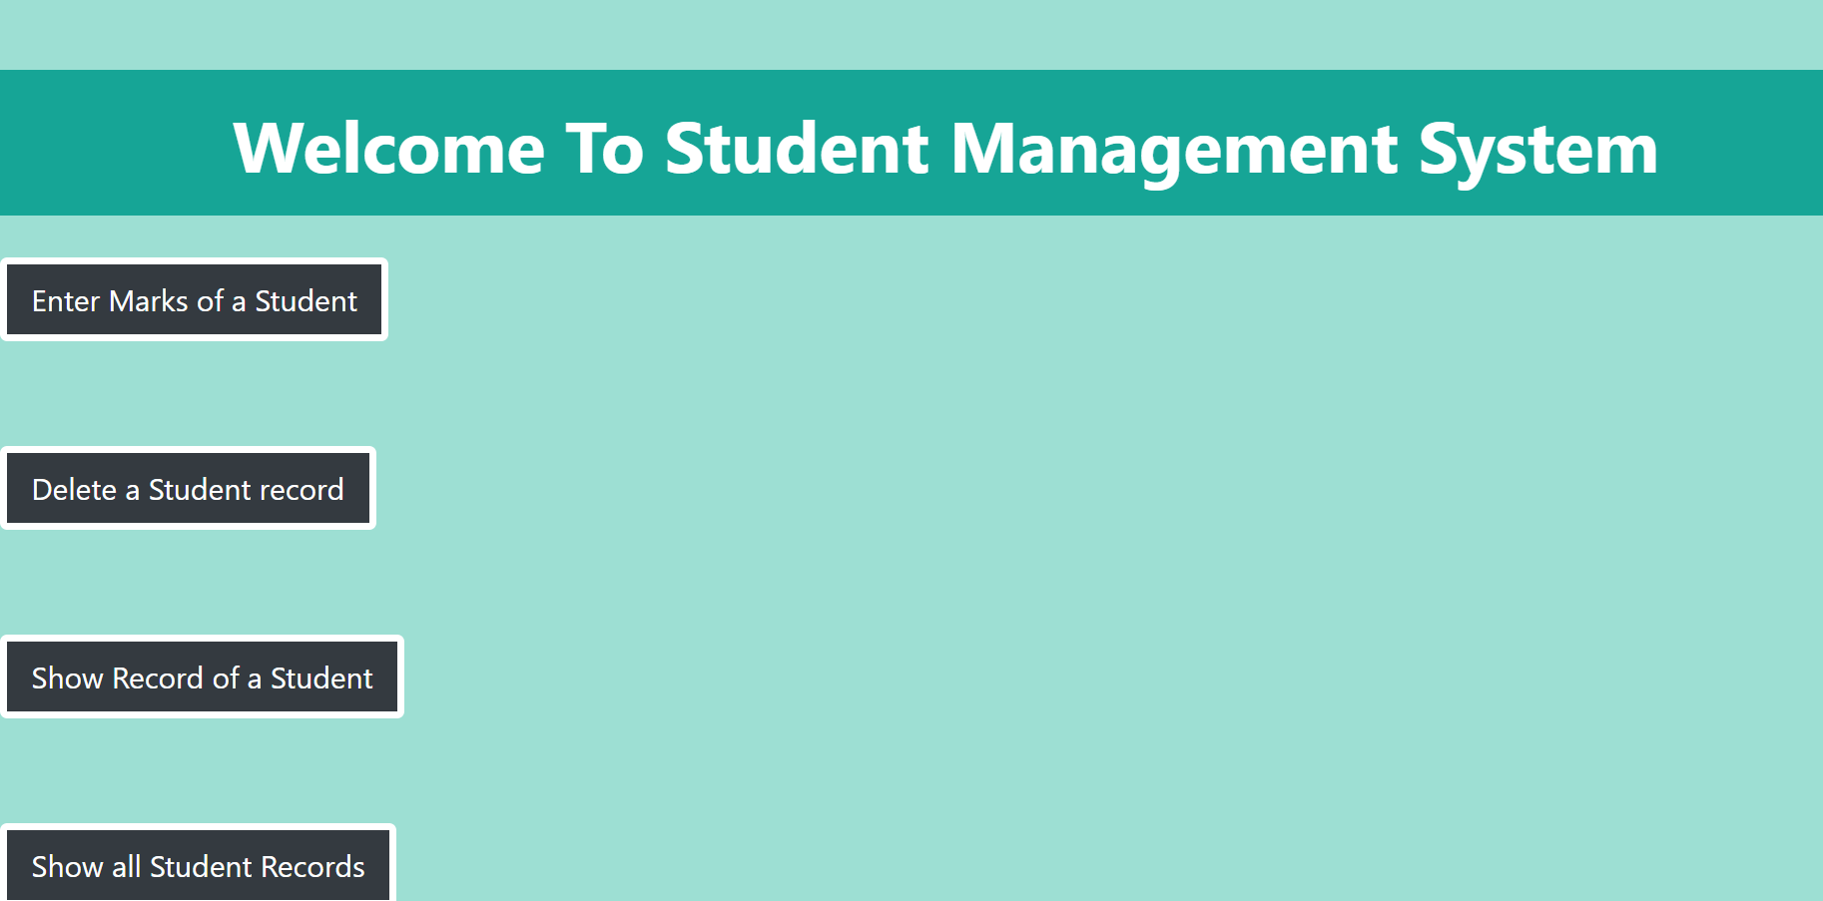

**Enter Marks Control**

app.get("/entermarks",function(req,res){ // handling enter marks request

res.render("entermarks");

});

var a,b,c,d,e ,f,cg;

app.post("/entry",function(req,res){ //parsing values given by user

a = parseInt(req.body.apm,10);

b = parseInt(req.body.coam,10);

c = parseInt(req.body.idbmsm,10);

d = parseInt(req.body.otam,10);

e = parseInt(req.body.mm,10);

cg = (((a+b+c+d+e)/5)/9.5) ;

f= cg.toFixed(2)*1.0;

console.log(f);

let post = {rollNumber: req.body.roll , APmarks: a , COAmarks: b , DBMSmarks: c , OTAmarks: d , Mmarks: e , cgpa: f};

let sql = "insert into students set ?";

db.query(sql,post, (err,result) =>{ // executing the query to insert data

if(err){

res.render("error");

}

else{

// alert("marks submitted");

res.redirect("/home");

}

});

});

**Enter marks HTML page**

<%- include("Header") -%>

<div class="entermarks">

<form class="em" action="/entry" method="post">

<input type="text" name="roll" value="" placeholder = "enter roll number">

<br>

<br>

<input type="text" name="apm" value="" placeholder = "enter AP marks">

<br>

<br>

<input type="text" name="coam" value="" placeholder = "enter COA marks">

<br>

<br>

<input type="text" name="idbmsm" value="" placeholder = "enter IDBMS marks">

<br>

<br>

<input type="text" name="otam" value="" placeholder = "enter OTA marks">

<br>

<br>

<input type="text" name="mm" value="" placeholder = "enter M3 marks">

<br>

<br>

<button type="submit" name="button" class="btn btn-danger btn-lg" >submit</button>

</form>

</div>

<%- include("Footer") -%>

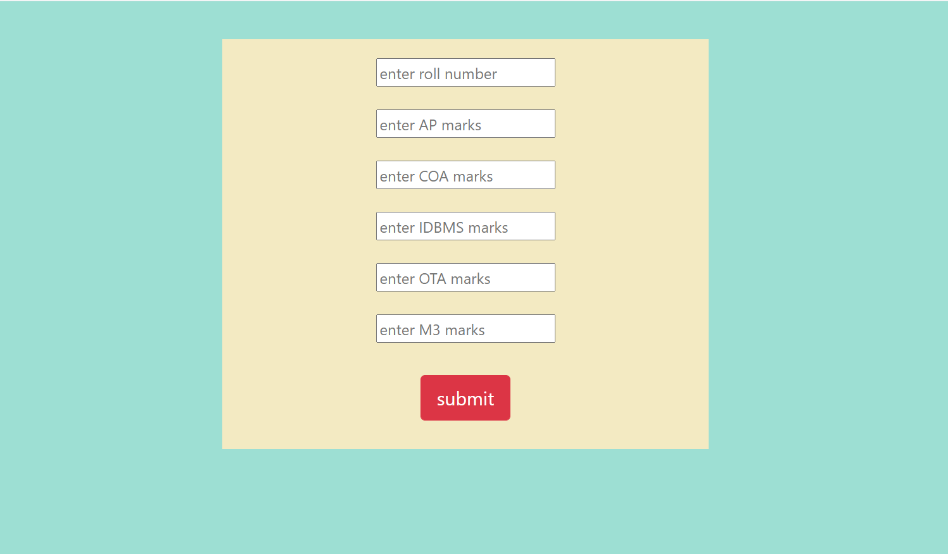

**Delete Control**

app.get("/deleterecord",function(req,res){ // rendering delete page

res.render("delete");

});

app.post("/deleterecord",function(req,res){

let sql = "delete from students where rollNumber = '" + req.body.roll + "' ";

db.query(sql,(err,result) => {

if(!result.affectedRows){

console.log(err);

res.render("error");

}

else{

// console.log(result.affectedRows);

res.redirect("/home");

}

});

});

**Delete HTML page code**

<%- include("Header") -%>

<h3> Enter the roll number of the student to be removed </h3>

<form class="" action="/deleterecord" method="post">

<input type="text" name="roll" value="" placeholder="enter roll number">

<button type="submit" name="button">Delete</button>

</form>

<a href="/home">Go To Homepage</a>

<%- include("Footer") -%>

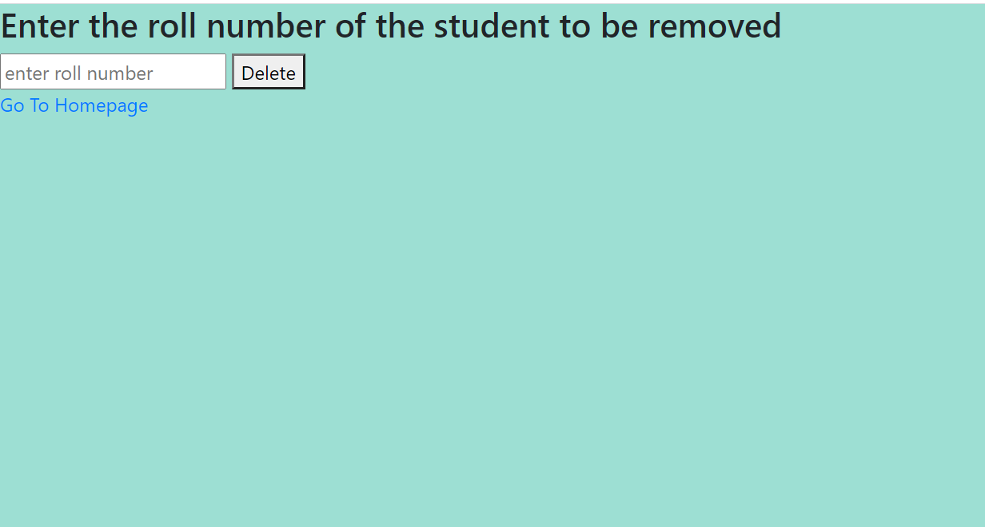

**Show Record Control**

app.get("/showrecord" , function(req,res){

res.render("showrecord");

});

app.post("/showrecord", function(req,res){

// let sql = "select * from students where rollNumber = '" + req.body.roll + "' ";

let sql = " select * from students s join stuDetail sd on s.rollNumber = sd.roll where s.rollNumber = '" + req.body.roll+"'";

db.query(sql,(err,result) => {

if(!result.length){

res.render("error");

}

else{

console.log(result);

res.render("showing",{record: result});

}

});

});

**Show record HTML code**

<%- include("Header") -%>

<br>

<br>

<h3> Enter the roll number of the student to show </h3>

<form class="" action="/showrecord" method="post">

<br>

<input type="text" name="roll" value="" placeholder="enter roll number">

<button type="submit" name="button">show</button>

</form>

<a href="/home">Go To Homepage</a>

<%- include("Footer") -%>

………………………………………………………………………………………………………...

<%- include("Header") -%>

<h2 class="srhead">Student Record</h2>

<div class="showrec">

<ul>

<li> Student Name: <%= record[0].firstName %> <%= record[0].lastName %> </li>

<li> Roll Number: <%= record[0].rollNumber %> </li>

<li> AP marks: <%= record[0].APmarks %> </li>

<li> COA marks : <%= record[0].COAmarks %> </li>

<li> IDBMS marks : <%= record[0].DBMSmarks %> </li>

<li> OTA marks : <%= record[0].OTAmarks %> </li>

<li> M3 marks : <%= record[0].Mmarks %> </li>

<li> Projected CGPA : <%= record[0].cgpa %> </li>

</ul>

</div>

<a href="/home">Go To Homepage</a>

<%- include("Footer") -%>

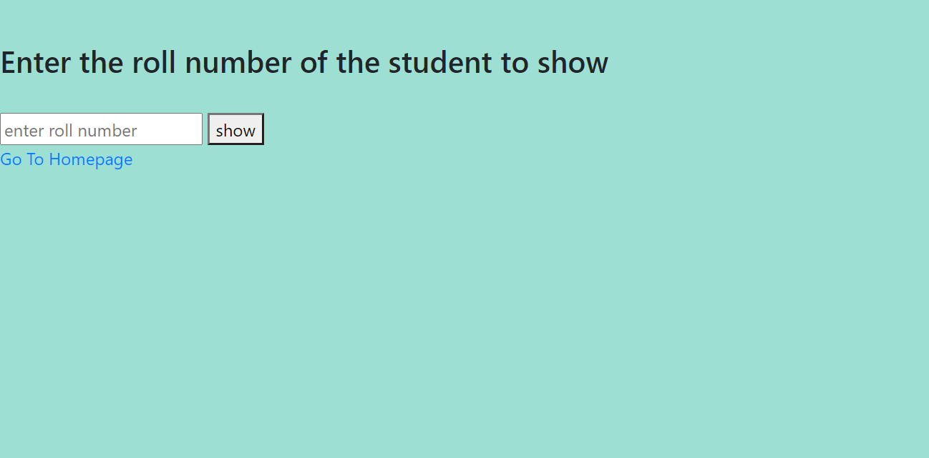

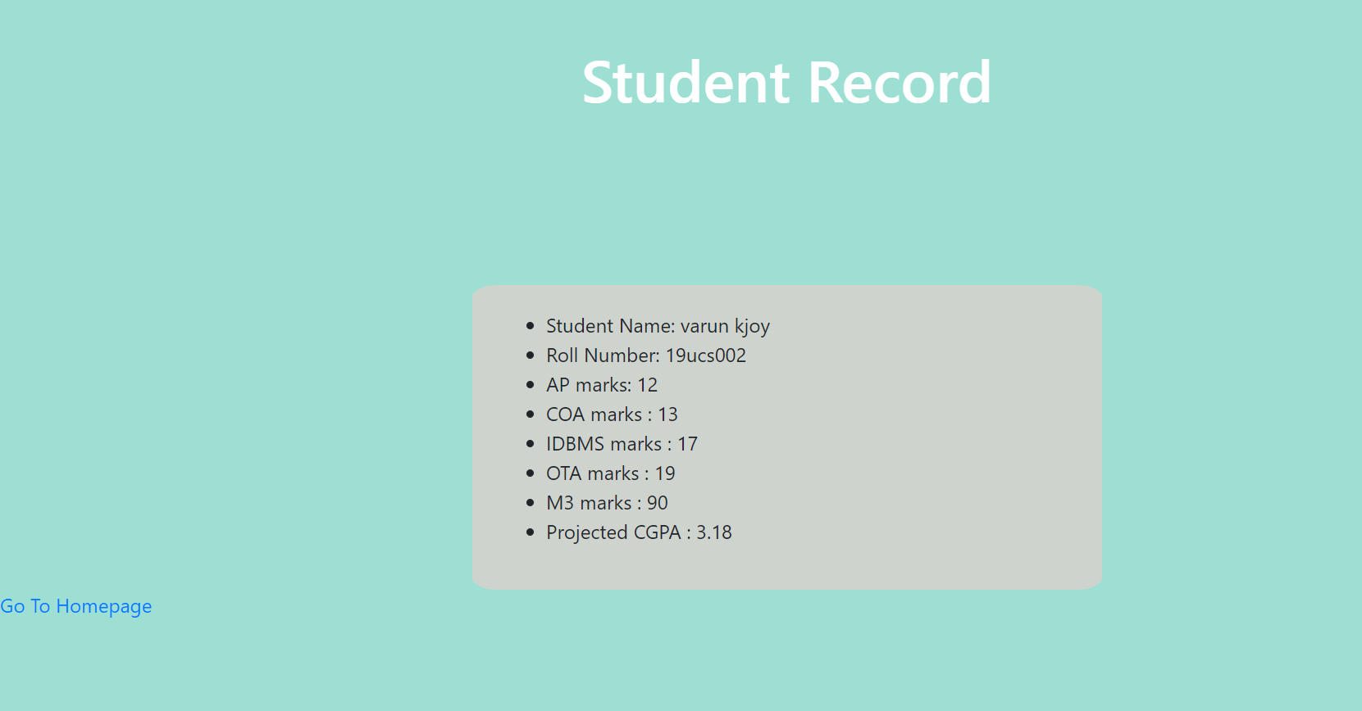

**Show All Records Control**

app.get("/showall",function(req,res){

let sql = "select * from students s join stuDetail sd on s.rollNumber = sd.roll order by rollNumber ;"

db.query(sql,(err,result) => {

if(!result.length){

console.log(result);

res.render("error");

}

else{

console.log(result);

res.render("showall" , {record: result});

}

});

});

**Show All HTML page**

<%- include("Header") -%>

<h2 class="srhead">Student Record</h2>

<% record.forEach((item, i) => { %>

<div class="showrec">

<ul>

<li> Student Name: <%= item.firstName %> <%= item.lastName %> </li>

<li> Roll Number: <%= item.rollNumber %> </li>

<li> AP marks: <%= item.APmarks %> </li>

<li> COA marks : <%= item.COAmarks %> </li>

<li> IDBMS marks : <%= item.DBMSmarks %> </li>

<li> OTA marks : <%= item.OTAmarks %> </li>

<li> M3 marks : <%= item.Mmarks %> </li>

<li> Projected CGPA : <%= item.cgpa %> </li>

</ul>

</div>

<% }); %>

<a href="/home">Go To Homepage</a>

<%- include("Footer") -%>

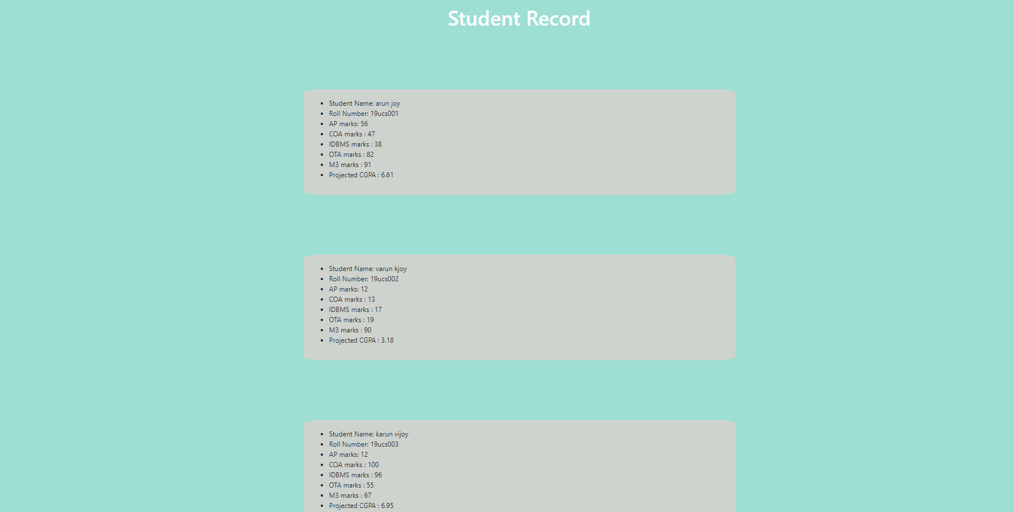

**ERROR Message**

**HTML code**

<%- include("Header") -%>

<h1> Invalid Request recieved ... </h1>

<a href="/home">Go To Homepage</a>

<%- include("Footer") -%>

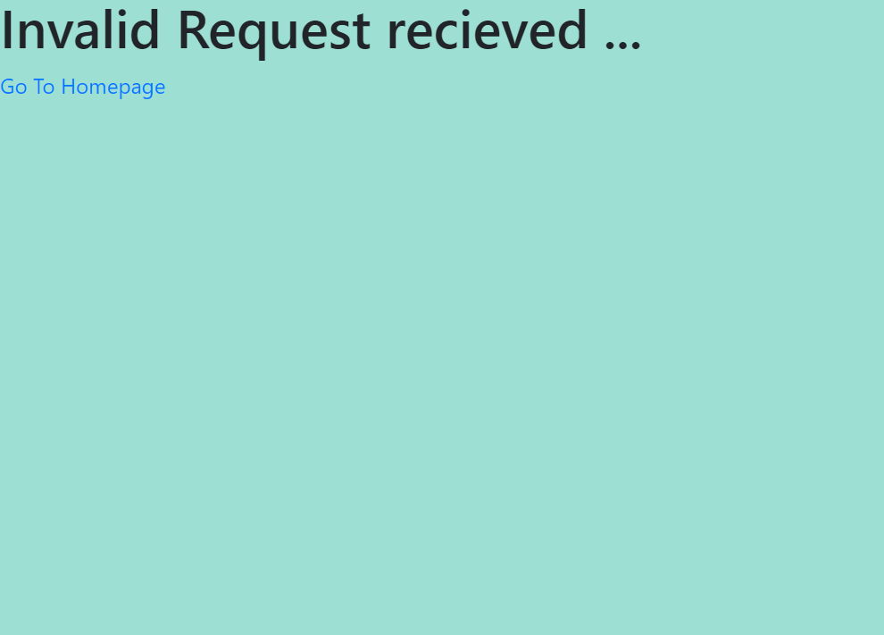

<-----END OF REPORT -------->